System Requirements Specification
for the
SynergySoft™ Distributed Meeting Scheduler

- Introduction

This document describes the enterprise, software system functional and non-functional requirements for the SynergySoft™ Distributed Meeting Scheduler product that is planned for product development in the near future.

The purpose of this document is to define the requirements gathering process used to elicit requirements from the product stakeholders, to define the overall vision and goals of this new product, and to list those functional and non-functional requirements that are essential to the success of this product.

This document was prepared with the understanding that establishing the proper vision and business objectives of any new software product and the proper documentation of a consistent, robust, well understood, and complete set of functional and non-functional requirements is essential for product success.

- References

IEEE Recommended Practice for Architectural Description of Software-Intensive Systems, IEEE Std. 1471-2000.

IEEE Recommended Practice for Software Requirements Specifications, IEEE Std. 830-1998.

IEEE Guide for Developing System Requirements Specifications, IEEE Std. 1233-1998.

- Definitions

agenda | A list of topics (and optionally names of persons to lead discussions with optional durations) to be discussed, reviewed, or decided upon at a meeting
confirmed meeting participant | A potential meeting participant after the participant has accepted (“will attend”) a meeting
date range | Range of dates acceptable for the proposed meeting
delegate | To have another person act on your behalf by authorizing them certain functions to perform
delegation | The act of establishing a delegate
duration | The time span of a proposed meeting
important | A designation given to a proposed meeting participant indicating a requirement for their attendance at a meeting else the meeting should not take place or should be rescheduled
location | The physical location of a proposed meeting including building and room number and possibly including the country, state, city.
meeting initiator | A person who starts the meeting scheduling process – who initiates a meeting proposal
meeting proposal | An invitation to a meeting including the meeting topic, date range, and duration that is sent to a list of potential meeting participants
meeting topic | The theme of or reason for the meeting
potential meeting participant | A person who has been invited to a proposed meeting that has not either accepted (“will attend”) or refused (“will not attend”)
propose a meeting | To suggest or to decide a meeting is needed
required equipment | Additional equipment, typically audio-visual equipment, needed in support of the meeting
timeslot | An available span of time in a potential meeting participant’s schedule of the required duration for the proposed meeting
virtual meeting | A meeting simultaneously held at multiple remote locations, e.g. teleconferencing
will attend | A state of a meeting invitation by an individual potential meeting participant indicating that the individual “will attend” the meeting
will not attend | A state of a meeting invitation by an individual potential meeting participant indicating that the individual “will not attend” the meeting

- Requirements Process

The requirements elicitation process is an engineering process that produces a consensus document containing the enterprise, software system functional, and software system non-functional requirements as developed through constructive interactions among the various stakeholders of the planned product.

This engineering process consists of “elicitation” of requirements through technical discussions, “specification” of requirements through textual and diagrammatic models, and “validation” of those requirements through confirmation of the models through discussions and presentations of those models.

Broadly speaking, these requirements answer the why, what, and how of the planned product across the community of stakeholders of the planned product.

Representatives are selected from the various stakeholder organizations by their respective management to participate in the requirements elicitation process and to represent the organizational needs and wants of the organizations and groups they represent.

These organizational stakeholders are broadly categorized into 4 “worlds” – subject, user, developer, and system representing 1) the subject matter or domain experts of the scheduling and meeting organization, 2) the product customers and eventual users of the meeting scheduling system, and 3) the software architects, designers, implementers, testers, and maintainers of the planned software system, resulting in 4) the stated requirements of the planned system.

  - Representatives

The representatives selected to participate in the requirements elicitation process are:

Yasaman Haghpanah - System world
Ravindra Rudraraju - Developer world
Sowjanya Sakruti - User world
Jim Whitaker - Subject world

  - Roles and Responsibilities

The role of the “subject world” representative is to provide meeting organization and coordination expertise in addition to scheduling expertise for the planned product.

The role of the “user world” representative is to provide expertise pertaining to user interface, intuitive operation, and overall usability of the planned product.

The role of the “developer world” representative is to provide expertise pertaining to the feasibility and desirability of alternatives of proposed requirements and the inclusion of industry standards and best practices for software development.

The role of the “system world” representative is to provide automation expertise and to represent the requirements of the proposed software product – the requirements engineer.

  - Process Requirements

The requirements elicitation process requirements are to produce a requirements specification that documents the formal requirements of the planned product as specified by the stakeholders of the product and provides adequate guidance to the development organization to achieve a successful product in a time and resource effective manner.

Guidance for this process is provided in the IEEE standards listed in the “References” section of this document.

Given the diversity of interests and approaches possible it is assumed that an adequate consensus cannot be achieved for all aspects of any non-trivial engineering effort. It is expected that due diligence be employed to investigate alternatives and to negotiate any requirement or requirements in conflict.

Issues remaining unresolved at the end of the requirements elicitation process shall be resolved by senior management in consultation with technical leadership prior to the completion of the requirements elicitation phase.

  - Outstanding Issues

Outstanding issues are those requirements or aspects of the planned product which have not been adequately resolved during the requirements elicitation process. Each issue is uniquely numbered, contains a title, description, and contact information for the representative sponsoring the issue.

Outstanding issues are resolved by senior management in consultation with technical leadership through an assessment of impact, analysis of alternatives, or other approach deemed appropriate. The method of analysis, disposition, and contact information of the person responsible for the decision is maintained as part of the requirements specification.

Outstanding issues are listed in Appendix A of this document.

- Product Requirements

  - Enterprise Requirements

    - Vision Statement

The SynergySoft™ Distributed Meeting Scheduler will provide convenient means of scheduling (and rescheduling) physical and virtual meetings among members of the organization regardless of their physical locations in an efficient and cost-effective manner.

    - Goals & Objectives

Goals and objectives related to the vision statement listed above:

- improved communication to meeting participants regarding aspects of the meeting (agendas, equipment, etc.) and changes to the planned meeting,

- optimized selection of location (meeting room) given the list of meeting participants,

- dynamic meeting “rescheduling” to offload the work required for rescheduling a meeting from the meeting initiator to the meeting scheduling system,

- support for virtual meetings with optional recording of the meeting for subsequent replay and archival storage,

- support for user authentication and authorization of features such as delegation to an administrative assistant or secretary,

- optimized implementation in terms of computational and network resources, human involvement and interaction, and rapid response times.

    - Operational Scenario

A “meeting initiator” would use the SynergySoft™ Distributed Meeting Scheduler to “propose a meeting” by providing the “meeting topic”, “date range”, “duration”, and “location” to a list of “potential meeting participants”.

The “meeting initiator” may designate one or more “potential meeting participants” as “important” meaning that their attendance at the meeting is required in order to have the meeting.

Potential meeting participants are identified by a unique identifier that relates to a profile containing the person’s name, address, telephone and fax numbers, other organizational information, and may contain a “delegation” to another person who is empowered to act on the person’s behalf.

The profile shall contain an attribute indicating whether or not the person is able to attend a “virtual meeting” – a meeting facilitated through teleconferencing on a computer.

The “meeting proposal” may include an “agenda” or list of topics for discussion during the meeting and may include a list of “required equipment”.

Upon entry of the “meeting proposal” to the scheduler, the scheduler will scan the list of “potential meeting participants” to determine of a “time slot” of the required “duration” exists among all “potential meeting participants”.

If no “time slot” exists, the scheduler will inform the “meeting initiator” that no “time slot” exists for all “potential meeting participants” and may optionally suggest an alternative “date range”, “duration”, and “location” which is available.

If the “date range” and “duration” is acceptable but no location for the meeting is available or feasible, a “virtual meeting” may be suggested for the available “time slot”.

The meeting scheduler may provide the “meeting initiator” a summary of the scan of “potential meeting participants” depicting available time slots and schedule conflicts as a means of informing the “meeting initiator” of the overall results of the scan.

If a “time slot” exists, the scheduler will temporarily reserve the “time slot” for the proposed meeting and inform the “potential meeting participant” of the meeting and request input as to “will attend” or “will not attend”.

A “potential meeting participant” or their “delegate” may either 1) accept the meeting (“will attend”) or 2) refuse the meeting (“will not attend”). When accepting a meeting, the “potential meeting participant” becomes a “confirmed meeting participant” and may request special equipment. When refusing a meeting, the “potential meeting participant” may provide a reason for the refusal.

Once all “potential meeting participants” have responded to the “meeting proposal”, the “meeting initiator” shall 1) confirm the meeting which will result in the “time slots” of accepting participants to be changed from a temporary reservation to a scheduled meeting, or 2) cancel the meeting which will result in the “time slots” being temporarily reserved to be freed, or 3) to replan the meeting by releasing the temporary reservations and selecting a different “date range”, “duration” or “location” and starting the process over.

At any time prior to the start of the meeting, the “meeting initiator” may cancel the meeting or replan the meeting. Similarly, a “potential meeting participant” or “confirmed meeting participant” may confirm or cancel their attendance at the meeting subject to the administrative rules and practices of the participant’s.

    - UML Diagrams

      - Use Case Diagram

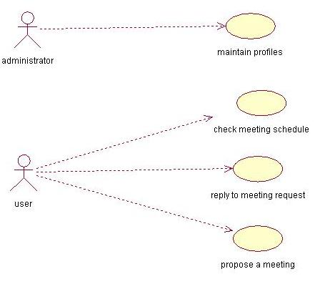

Figure 1 Use Case Diagram

The above use case diagram shows the functionality of the SDMS system. The
whole SDMS system can be viewed in two perspectives. As an administrator you have the privilege to maintain profiles of the users. And as a user you can check your meeting schedules, reply to meeting requests or propose a meeting.

      - Sequence Diagram

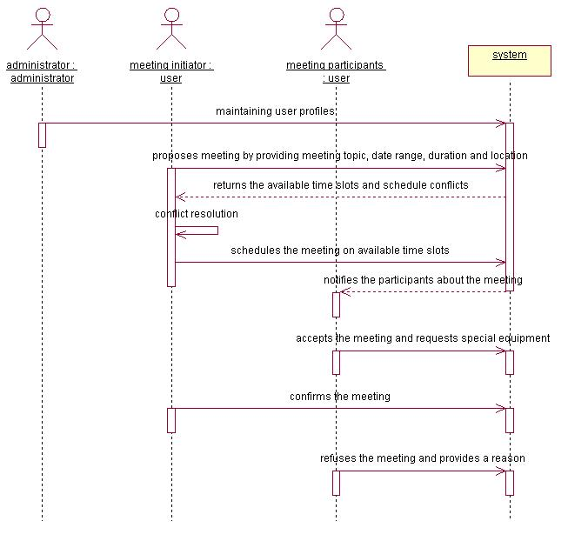

Figure 2 Sequence Diagram

The above diagram shows us the sequence of messages exchanged among the roles in the system. It shows the flow of control among administrator, users (meeting initiator, meeting participants) and system that collaborate in the context of the scenario.

      - Domain Model

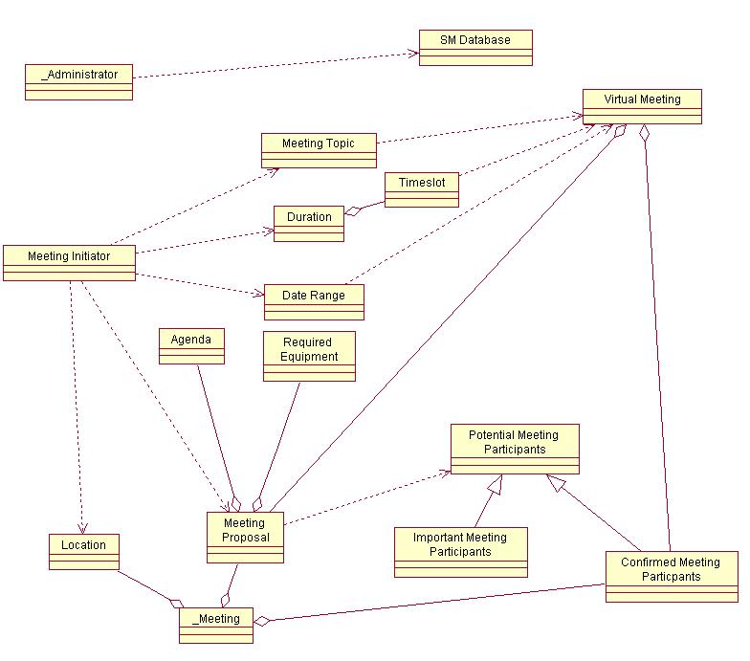
Figure 3 Domain Model

The above domain model tells us about the various entities involved and their relationships. The domain model is created to understand the key concept of the system and to familiarize with the vocabulary of the system.

    - Enterprise Functional Requirements

EFR-1 | A “meeting initiator” shall initiate a meeting by deciding on a “meeting topic”, by selecting a list of “potential meeting participants”, and by selecting a “date range”, “duration”, and “location” for the meeting.
EFR-2 | A “meeting initiator” or “potential meeting participant” shall provide the ability where a person may “delegate” the ability to initiate or accept (or decline) a meeting to another system user.
EFR-3 | A “meeting initiator” shall be one of the “potential meeting participants” by default but may opt to remove himself as a “potential meeting participant”.
EFR-4 | A “meeting initiator” shall confirm the meeting and the system shall change the “time slots” of accepting “meeting participants” from a temporary reservation to a scheduled meeting, once all “potential meeting participants” have responded to the “meeting proposal.
EFR-5 | A “meeting initiator” shall cancel the meeting and the system shall change the “time slots” from being temporarily reserved to be freed once the meeting is canceled.
EFR-6 | A “meeting initiator” shall reschedule the meeting and the system reschedule the meeting by releasing the temporary reservations and selecting a different “data range”, “duration”, or “location” and starting the process over.
EFR-7 | A “meeting initiator” may send a “meeting proposal” for a “virtual meeting” for the available “time slot” if the “date range” and “duration” is acceptable but no location for the meeting is available.
EFR-8 | A “meeting initiator” may cancel the meeting or reschedule the meeting at any time prior to the start of the meeting.
EFR-9 | A meeting scheduler may (optionally) automatically propose another meeting if current meeting is canceled by an important participant.
EFR-10 | A meeting scheduler may provide the “meeting initiator” a summary of the scan of “potential meeting participants” showing available “time slots” and schedule conflicts as a means of informing the “meeting initiator” of the overall results of the system.
EFR-11 | The “meeting initiator” may designate one or more “potential meeting participants” as “important” meaning that their attendance at the meeting is required in order to have the meeting.
EFR-12 | The “meeting proposal” may include an “agenda” or list of topics for discussion during the meeting and may include a list of “required equipments”.
EFR-13 | A meeting scheduler will scan all the list of “potential meeting participants” to determine a “time slot” of the required “duration” exists among all “potential meeting participants” once a “meeting proposal” is entered to the system.
EFR-14 | A meeting scheduler will inform the “meeting initiator” that no “time slot” exists for all “potential meeting participants” and may optionally suggest an alternative “date range”, “duration”, and “location” which is available.
EFR-15 | A meeting scheduler will temporarily reserve the “time slots” for the proposed meeting and inform the “potential meeting participant” of the meeting and request input as to “will attend” or “will not attend”, if a “time slot” exists.
EFR-16 | A “potential meeting participant” or their “delegate” may accept or refuse the meeting. If accepting, the “potential meeting participant” becomes a “confirmed meeting participant”. If refusing, the “potential meeting participant” may provide a reason for his refusal.
EFR-17 | A “confirmed meeting participant” may request special equipment.
EFR-18 | A “potential meeting participant” or “confirmed meeting participant” may confirm or cancel their attendance at the meeting subject to the administrative rules and practices of the participant’s.

    - Enterprise Non-Functional Requirements

ENFR-1 | Any physical changes to the “location” and its “required equipment” shall be kept up-to-date.
ENFR-2 | : If any physical changes to the “location” and its “required equipments” shall occur after a “meeting proposal” and before the meeting date, the “meeting initiator” shall be notified promptly.

  - Software System Functional Requirements

The purpose of the SDMSTM system is to support the organization of meetings. The system shall analyze each meeting request to determine a meeting date and location so that most of the intended participants will effectively participate.

SFR-1 | The meeting scheduler system shall be able to schedule a meeting with a meeting topic, date range, duration, and location for a list of participants.
SFR-2 | The meeting scheduler system shall monitor meetings, since some of the meeting held as a “virtual meeting”.
SFR-3 | The meeting scheduler system shall be able to select a participant as an important participant.
SFR-4 | The meeting scheduler system shall cancel a meeting due to canceling of an important participant.
SFR-5 | The meeting scheduler system shall reschedule a meeting to support conflict resolutions.
SFR-6 | The meeting scheduler shall be accessed from the Web.
SFR-7 | The meeting scheduler system may (optionally) automatically propose another meeting if current meeting is canceled by an important participant.
SFR-8 | The meeting scheduler system may provide the “meeting initiator” a summary of the scan of “potential meeting participants” showing available “time slots” and schedule conflicts as a means of informing the “meeting initiator” of the overall results of the system.
SFR-9 | The meeting scheduler system may be able to include an agenda for a meeting proposal.
SFR-10 | The meeting scheduler system may suggest a “virtual meeting” for available “time slots” if no location is available or feasible for the meeting.
SFR-11 | The meeting scheduler system may be able to include a list of required equipment for a meeting proposal.
SFR-12 | A meeting scheduler system will temporarily reserve the “time slots” for the proposed meeting.
SFR-13 | A meeting scheduler system will inform the “potential meeting participant” of the meeting.

  - Software System Non-Functional Requirements

A good Meeting Scheduler system should meet the powerful functional requirement. It should also pay attention to its non-fictional requirements. This section describes the quality attributes that the Meeting Scheduler software should have.

    - Reliability
The SDMSTM system should emulate or imitate the manner in which human without automation schedules meetings.

    - Performance
The elapsed time between the submission of a meeting request and the determination of the corresponding date or location should be upon the “meeting participants” count. If they are less than 20 people the elapsed time shall be less than 4 seconds, If the count is between 20 and 50, the elapsed time shall be less than 10 seconds. If the count is more than 50 the elapse time can vary from 10 seconds to 40 seconds.

    - User friendliness
The user interface of the system should be easily usable by non-experts. It means that the SDMSTM system should reflect as closely as possible to the way non-automatic meetings are typically managed

    - Flexibility
Rescheduling of a meeting should be done dynamically.

    - Extensibility
The meeting scheduler system has the ability to handle explicit dependencies between meeting date and meeting location. Then again, it manages participation through “delegation”.

    - Security
Privacy rules should be enforced a “meeting participant” should not be aware of constraints stated by other “meeting participants”

  - Requirements Traceability

APPENDIX A – Outstanding Issues

Issue # | ISSUE-1
Title | Conflicting and Confusing Initial Requirements
Description | The initial requirements specification contains conflicting requirements, confusing statements, is unorganized, and is generally unusable as an initial requirements specification.
Contact | Yasaman Haghpanah (“system” world representative)
Analysis/Alternatives | 1) request updated/improved initial requirements specification, 2) restate the understood requirements into an operational scenario and improve the scenario as requirements are found and issues resolved
Disposition | 2) Decided to develop an operational scenario as a consensus document based on the information gleaned from the initial requirements specification
Contact | The 4 representatives – team decision

Issue # | ISSUE-2
Title | Meeting Initiator a Potential Meeting Participant
Description | Is the meeting initiator treated like any other potential meeting participant or should the meeting initiator be a confirmed participant when proposing a meeting?
Contact | Sowjanya Sakruti (“user” world representative)
Analysis/Alternatives | Default is “yes” or “no” or requires a selection
Disposition | Meeting initiator is a pre-confirmed participant of any meeting initiated by the meeting initiator
Contact | Jim Whitaker (“subject” world representative)

Issue # | ISSUE-3
Title | Definition of an “important” person
Description | What is an “important” person – how is this determined – what effect does it have on the system?
Contact | Ravindra Rudraraju (“developer” world representative)
Analysis/Alternatives | An important person is determined by the meeting initiator as a person “required” to be present at the meeting otherwise the can/should not be held.
Disposition | A meeting shall only be scheduled if all “important” participants are available and are willing to attend the meeting – otherwise the meeting should not be held.
Contact | Sowjanya Sakruti (“user” world representative)

APPENDIX B – Preliminary Design (Mockup)

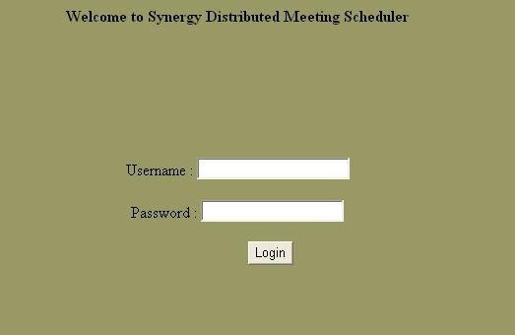
Figure 4 Login Screen

The purpose of this web page is to authenticate the user.

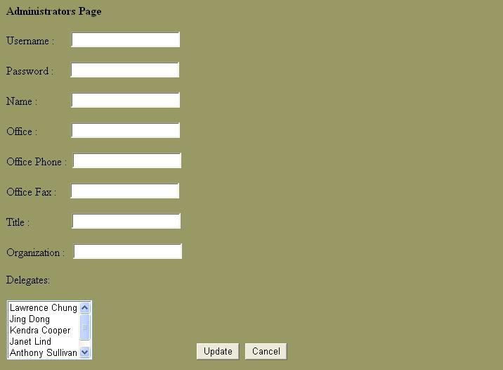
Figure 5 Administrators Page

The purpose of this web page is for maintaining the user profiles by the administrator.

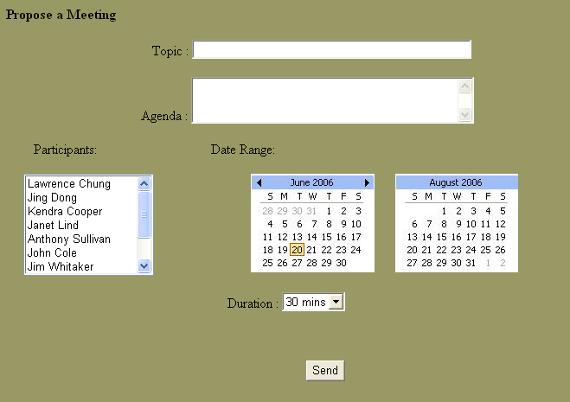
Figure 6 Propose a meeting

When the user wants to propose a meeting he uses the above page. He provides the topic, agenda, data range and duration of the meeting along with the meeting proposal to potential meeting participants.


Figure 7 View Schedule

The user can view his schedule for a day or week or month depending on his necessity using the above page. The priorities of the meetings are shown by color. The user responds by clicking on particular meeting.

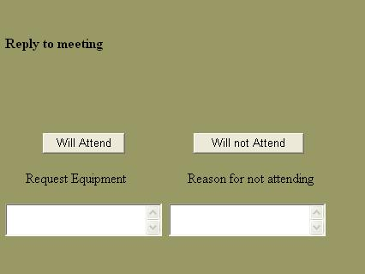
Figure 8 Reply to meeting

This page is displayed when the user clicks on meeting. The user responds either by clicking “will attend” button or “will not attend” button. If the user is attending the meeting he may request for equipment. If the user is not willing to attend the meeting he may give a reason for his absence.

